Game Design Document

Fill up the Following document

1. Write the title of your project.

Pacific Rim

1. What is the goal of the game?

For the player to destroy all the kaiju and win the game.

1. Write a brief story of your game?

The kaiju came from the beach under the ocean and 3 came out of it the first one is called otachi and can fly which is a Cat 4 kaiju. The 2nd one is called Slattern which is the hardest the Pan Pacific Defense Corp has ever faced. It is a Cat 5 kaiju. The last one called the Mega Kaiju is 3 kaiju combined. The 3 kaiju were 2 Cat 4’s and a Cat 5. Gipsy Avenger who is the main character is a Mark-6 Yager and is the leader of 6th and 7th Jager Fleet.

1. Which are the playing characters of this game?

* Playing characters are the ones which respond to the user based on the input from the user
* Cars, monkeys, dinos, wizards etc, are the playing characters in the game.

|  |  |  |
| --- | --- | --- |
| Number | Character Name | What can this character do? |
| 1 | Gipsy Avenger | He can used 2 moves Rocket Punch and Gravity Gun |
| 2 |  |  |
| 3 |  |  |
| 4 |  |  |
| 5 |  |  |
| 6 |  |  |
| 7 |  |  |
| 8 |  |  |

1. Which are the Non Playing Characters of this game?

* Non Playing characters are the ones which don't have an action or a behaviour when the user interacts with the game.
* Hurdles, stones, bananas, coins, etc are non playing characters in the game.

|  |  |  |
| --- | --- | --- |
| Number | Character Name | What can this character do? |
| 1 | Otachi | For this kaiju I did nothing because she really doesnt have any special moves. |
| 2 | Slattern | He can use his tails to short circuit yager and has been know to survive a Mark 5- Jaeger Self Detonation. |
| 3 | Mega Kaiju | Is 3 kaiju in one and can throw spikes out of its tail. The only way it was defeated is when Gipsy Avenger Slammed into the back of its brain killing it with a rocket. |

Draw your imagination of this game. What does this game look like?

* Draw the game either on your computer or on paper,
* Add images of scenes of the game to show each of the playing and non-playing characters at least once.

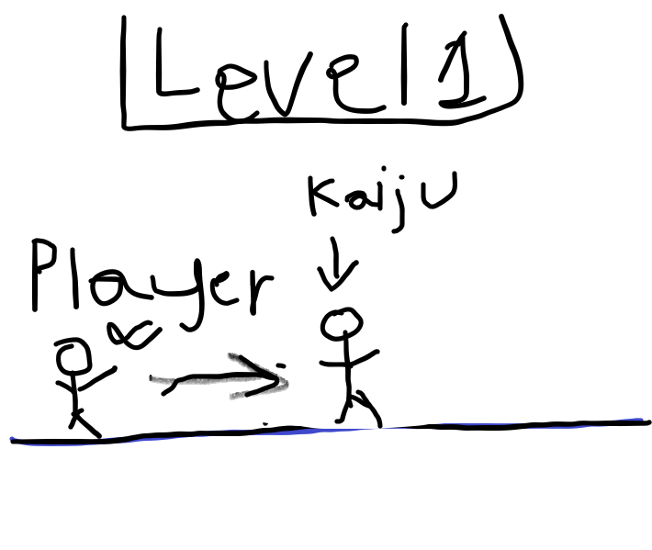

How do you plan to make your game engaging?

Im gonna give feedback to the player after every kill’s a kaiju. By saying good job or nice work.